**REPORT ON DATA ANALYSIS OF ROAD SAFETY**

J Vishal

Artificial Intelligence and Data Science

Rajalakshmi Institute of Technology

Chennai, India

[vishal.j2021.ad@ritchennai.edu.in](mailto:vishal.j2021.ad@ritchennai.edu.in)

R Reshma

Artificial Intelligence and Data Science

Rajalakshmi Institute of Technology

Chennai, India

[reshma.r.2021.ad@ritchennai.edu.in](mailto:reshma.r.2021.ad@ritchennai.edu.in)

P Yuvaraj

Artificial Intelligence and Data Science

Rajalakshmi Institute of Technology

Chennai, India

[yuvaraj.p.2021.ad@ritchennai.edu.in](mailto:yuvaraj.p.2021.ad@ritchennai.edu.in)

Mentor Name: S Saranya

Artificial Intelligence and Data Science

Rajalakshmi Institute of Technology

Chennai, India

[saranya.s@ritchennai.edu.in](mailto:saranya.s@ritchennai.edu.in)

tributes

**ABSTRACT:**

This report presents a thorough analysis of road safety data, aiming to provide insights into the factors influencing road accidents and fatalities. The analysis utilizes a vast dataset of traffic-related incidents, encompassing various parameters such as vehicle types, latitude, longitude, speed, time, and so on. Key findings include the identification of high-risk areas prone to accidents. The report concludes with a recommendation for policy enhancements and targeted interventions, emphasizing the importance of data-driven-decision-making in the ongoing efforts to reduce road accidents and enhance overall road safety.

**INTRODUCTION:**

* From understanding the data set provided for analysis, the change in road safety that was collected from the road events from the AI-based ADAS device, helps us to change the collisions between vehicles.
* The challenge we faced was funding the model and high-traffic alert area as this area needs to be focused on security. This needs for data cleaning and transformation and cleaning were done using Microsoft Excel.
* For geographic analysis, we use Kepler. gl to play the changed area information with the appropriate latitude and longitude.

**ABOUT DATASET:**

The given dataset contains the follows,

1. **FCW**- Forward Collision Warning
2. **HMW**- Headway Monitoring Warning
3. **LDW**- Lane Departure Warning
4. **PCW**- Pedestrian Collision Warning

We also have a data column that contains the time, latitude, longitude, vehicle and speed.

With this data, we are able to derive an overview of the traffic warning area.

**ANALYSIS:**

* **On the data analysis, we have insight with total count of 21325.**

|  |  |
| --- | --- |
| Maximum speed | 65 |
| Minimum speed | 0 |
| Average speed | 38.34966216 |

**FORWARD COLLISION WARNING:**

In the forward collision,

* The vehicle type **805** holds a count of **158**
* The vehicle type **5339** holds a count of **204**
* The vehicle type **2846** holds a count of **145**
* The vehicle type **1995** holds a count of **1**
* The vehicle type **3143** holds a count of **82**

The total count of the forward collision warning is **590.**

|  |  |
| --- | --- |
| Maximum speed | 63 |
| Minimum speed | 0 |
| Average speed | 36.34966216 |

**HEADWAY MONITORING WARNING:**

In the headway monitoring,

* The vehicle type **805** holds a count of **4227**
* The vehicle type **5339** holds a count of **4117**
* The vehicle type **2846** holds a count of **2409**
* The vehicle type **1995** holds a count of **8**
* The vehicle type **3143** holds a count of **1567**

The total count of the headway monitoring warning is **12328**

|  |  |
| --- | --- |
| Maximum speed | 64 |
| Minimum speed | 0 |
| Average speed | 35.3166 |

**LANE DEPARTURE WARNING:**

In the lane departure,

* The vehicle type **805** holds a count of **2052**
* The vehicle type **5339** holds a count of **754**
* The vehicle type **2846** holds a count of **2741**
* The vehicle type **1995** holds a count of **8**
* The vehicle type **3143** holds a count of **876**

The total count of the lane departure warning is **6431**

|  |  |
| --- | --- |
| Maximum speed | 65 |
| Minimum speed | 0 |
| Average speed | 50.92349557 |

**PEDESTRIAN COLLISION WARNING:**

In the pedestrian collision,

* The vehicle type **805** holds a count of **438**
* The vehicle type **5339** holds a count of **767**
* The vehicle type **2846** holds a count of **391**
* The vehicle type **1995** holds a count of **1**
* The vehicle type **3143** holds a count of **379**

The total count of the pedestrian collision warning is **1976**

|  |  |
| --- | --- |
| Maximum speed | 61 |
| Minimum speed | 0 |
| Average speed | 17.52733 |

**OBSERVATIONS:**

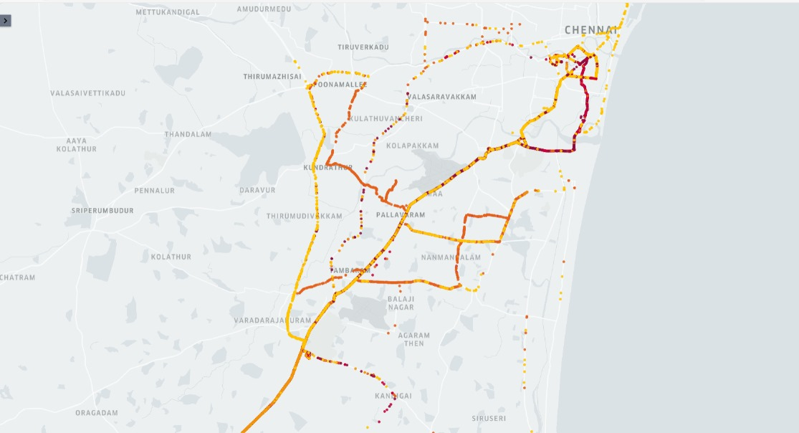

* This map represents the traffic alert area in southern region of Tamil Nadu.
* The above colours represents the following alert areas

1. Maroon - Headway Monitoring Warning
2. Orange - Lane Departure Warning
3. Red – Pedestrian Collision Warning

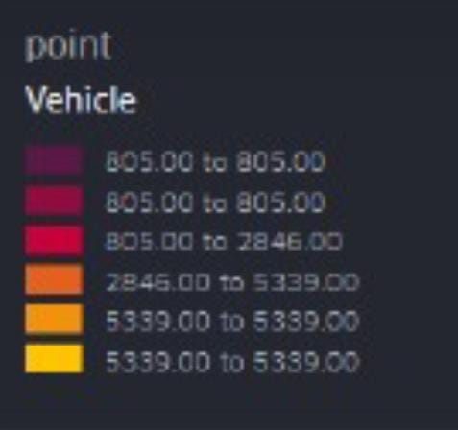

* From this we conclude that Headway Monitoring Warning causes the highest traffic alert in the southern region.
* The Lane Departure Warning causes the second most highest traffic alert in the southern region.
* The Pedestrian and the Forward Collision Warning causes the least traffic alert in the southern region.

**CONCLUSION:**

In conclusion, the data analysis on road safety has revealed critical insights into the factors contributing to accidents and potential avenues for improvement. Key findings include the significance of driver behavior, the impact of road infrastructure, and the role of vehicle safety features. This analysis underscores the need for comprehensive strategies that encompass education, enforcement, and engineering to enhance road safety and reduce accidents, ultimately saving lives and preventing injuries on our roads. Further research and continued data collection are essential to refine these strategies and make our roads even safer in the future.

.